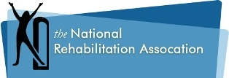
Call for Nominations
The National Rehabilitation Association is seeking candidates for election for the following three positions:
President Elect
Board Member at Large
Secretary
If you or a colleague, who is a member of the National Rehabilitation Association, is interested in an opportunity for a leadership position on the National Rehabilitation Association Board of Directors, please contact:
Bonnie Henn, Nominations Chairman for 2019
Bonnie.henn@dars.virginia.gov
Subject line: Nomination - <insert position of interest>
Nominations will close July 20, 2019
Thank you!

