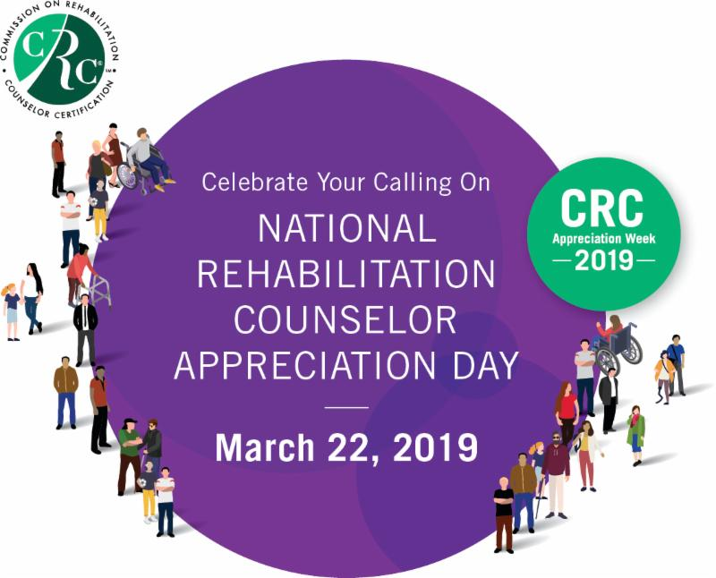
VISIT us at crccertification.com as well as on Facebook and LinkedIn to join us in the celebration:
SHARE our message with other counselors you work with to show your appreciation, and use the hashtag #CRCAppreciationWeek

POST your own messages and photos online

TELL your stories to your co-workers

CELEBRATE each other!
WATCH for our video on National Counselor Appreciation Day,
March 22, 2019, that honors your achievements
#CRCAppreciationWeek

